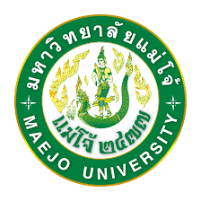

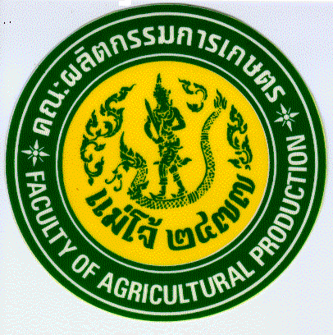FACULTY OF AGRICULTURAL PRODUCTION, MAEJO UNIVERSITY

Certificate of Training
is hereby granted to:
Mr.Phommasone PHONEPADITH
On successful completion of
Cultivation of Economic Mushrooms in Thailand
At Maejo Mushroom Learning Base, Faculty of Agricultural Production
26 – 28 September 2016

.…………………………….………………………… …………………………………………………….…..
(Mr.Sunchai MOKDA) (Asst.Prof.Dr.Ruangchai JUWATTANASOMRAN)
Head of Maejo Mushroom Learning Base Dean

FACULTY OF AGRICULTURAL PRODUCTION, MAEJO UNIVERSITY

Certificate of Training
is hereby granted to:
Mr.Hyunchul DO
On successful completion of
Cultivation of Economic Mushrooms in Thailand
At Maejo Mushroom Learning Base, Faculty of Agricultural Production
26 – 28 September 2016

.…………………………….………………………… …………………………………………………….…..
(Mr.Sunchai MOKDA) (Asst.Prof.Dr.Ruangchai JUWATTANASOMRAN)
Head of Maejo Mushroom Learning Base Dean

FACULTY OF AGRICULTURAL PRODUCTION, MAEJO UNIVERSITY

Certificate of Training
is hereby granted to:
Mr.Aot OUTHAI
On successful completion of
Cultivation of Economic Mushrooms in Thailand
At Maejo Mushroom Learning Base, Faculty of Agricultural Production
26 – 28 September 2016

.…………………………….………………………… …………………………………………………….…..
(Mr.Sunchai MOKDA) (Asst.Prof.Dr.Ruangchai JUWATTANASOMRAN)
Head of Maejo Mushroom Learning Base Dean

FACULTY OF AGRICULTURAL PRODUCTION, MAEJO UNIVERSITY

Certificate of Training
is hereby granted to:
Mr.Chanh CHANHSOUDA
On successful completion of
Cultivation of Economic Mushrooms in Thailand
At Maejo Mushroom Learning Base, Faculty of Agricultural Production
26 – 28 September 2016

.…………………………….………………………… …………………………………………………….…..
(Mr.Sunchai MOKDA) (Asst.Prof.Dr.Ruangchai JUWATTANASOMRAN)
Head of Maejo Mushroom Learning Base Dean

FACULTY OF AGRICULTURAL PRODUCTION, MAEJO UNIVERSITY

Certificate of Training
is hereby granted to:
Mr.Srichanh KEOVONGSID
On successful completion of
Cultivation of Economic Mushrooms in Thailand
At Maejo Mushroom Learning Base, Faculty of Agricultural Production
26 – 28 September 2016

.…………………………….………………………… …………………………………………………….…..
(Mr.Sunchai MOKDA) (Asst.Prof.Dr.Ruangchai JUWATTANASOMRAN)
Head of Maejo Mushroom Learning Base Dean

FACULTY OF AGRICULTURAL PRODUCTION, MAEJO UNIVERSITY

Certificate of Training
is hereby granted to:
Mr.Somesai PANMIESAI
On successful completion of
Cultivation of Economic Mushrooms in Thailand
At Maejo Mushroom Learning Base, Faculty of Agricultural Production
26 – 28 September 2016

.…………………………….………………………… …………………………………………………….…..
(Mr.Sunchai MOKDA) (Asst.Prof.Dr.Ruangchai JUWATTANASOMRAN)
Head of Maejo Mushroom Learning Base Dean

FACULTY OF AGRICULTURAL PRODUCTION, MAEJO UNIVERSITY

Certificate of Training
is hereby granted to:
Ms.Yen VIRATHONG
On successful completion of
Cultivation of Economic Mushrooms in Thailand
At Maejo Mushroom Learning Base, Faculty of Agricultural Production
26 – 28 September 2016

.…………………………….………………………… …………………………………………………….…..
(Mr.Sunchai MOKDA) (Asst.Prof.Dr.Ruangchai JUWATTANASOMRAN)
Head of Maejo Mushroom Learning Base Dean

