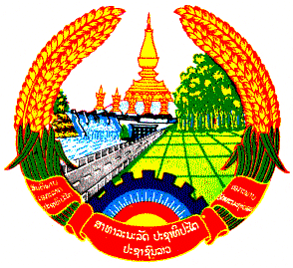

Lao people’s Democratic Republic
Peace Independence Democracy Unity Prosperity

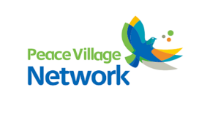
Department of Agriculture No:………………../PVN
Bokeo: ………………..…..

Houaysai District,
Bokeo Province
Tel: +865 84 212 374 (Lao) 0969819569 (Thai)
Subject: Invite the lecturer
Dear Sir. Dean of the Faculty of Agricultural Production.

Peace Village Network ( PVN ) is one Non - Government Organization ( NGO ) base in Huaysai District Bokeo Province Lao PDR. We are running Agricultural Support, Education Support and Livelihood Improvement for the people in Phaoudom and Paktha District, Bokeo Province from 2013 - 2018. According to our plan in this year 2016. We are going to support three families to grow mushroom in Paktha District, so on 20 – 25 August, 2016 we will open mushroom training course for them.

Peace Village Network , we consider that Mr Shanchai MOUKDA who expert about mushroom in Faculty of Agricultural Production , Maejo University is suitable to be our lecturer for this training course. Therefore we would like to warmly invite him to come and give lecture to participants on 20 - 25 August, 2016 at Paktha District Bokeo Province Lao.

So we are writing this letter to ask for your permission. We hope you will consider accepting this request. We are waiting to hear from you soon.

Thank you and
Yours Sincerely

Director of Peace Village Network

