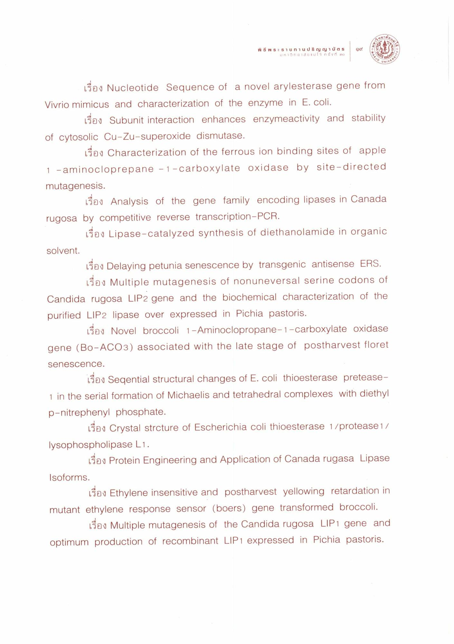

เรื่อง Nucleotide Sequence of a novel arylesterase gene from Vivrio mimicus and characterization of the enzyme in E. coli.
เรื่อง Subunit interaction enhances enzymeactivity and stability of cytosolic Cu-Zu-superoxide dismutase.
เรื่อง Characterization of the ferrous ion binding sites of apple 1 -aminocloprepane - 1 - carboxylate oxidase by site-directed mutagenesis.
เรื่อง Analysis of the gene family encoding lipases in Canada rugosa by competitive reverse transcription-PCR.
เรื่อง Lipase-catalyzed synthesis of diethanolamide in organic solvent.
bag Delaying petunia senescence by transgenic antisense ERS.
เรื่อง Multiple mutagenesis of nonuneversal serine codons of Candida rugosa LIP2 gene and the biochemical characterization of the purified LIP2 lipase over expressed in Pichia pastoris.
เรื่อง Novel broccoli 1-Aminoclopropane-1-carboxylate oxidase gene (Bo-ACO3) associated with the late stage of postharvest floret senescence.
เรื่อง Seqential structural changes of E. coli thioesterase pretease1 in the serial formation of Michaelis and tetrahedral complexes with diethyl p-nitrephenyl phosphate.
เรื่อง Crystal strcture of Escherichia coli thioesterase 1/protease 1 / lysophospholipase L1.
เรื่อง Protein Engineering and Application of Canada rugasa Lipase Isoforms.
thylene insensitive and postharvest yellowing retardation in mutant ethylene response sensor (boers) gene transformed broccoli.
เรื่อง Multiple mutagenesis of the Candida rugosa LIP1 gene and optimum production of recombinant LIP1 expressed in Pichia pastoris.

